**Name = PREETI**

**Email Id = preeti030mca20@igdtuw.ac.in**

**Course = Master Of Computer Applications**

**Department = Information Technology**

**Year and Semester = 1st Year and 1st Semester**

**Enrollment Number = 03204092020**

**Application Number = IGDTUW\MCA\2000407**

**ADMIN PANEL**

Administration side of the store is where you can modify features, upload images, add vendors, add categories, add coupon and keep track of customers and much more.

To run this program extract the source code from my github repository.

LINK = [**https://github.com/Preeti-Pradhan/IT-PROJECT-ADMIN-WORK**](https://github.com/Preeti-Pradhan/IT-PROJECT-ADMIN-WORK)

To watch the demo of admin panel

LINK = [**https://youtu.be/9kWhJ8Vjch8**](https://youtu.be/9kWhJ8Vjch8)

**ROLE OF ADMIN**

* Login Page
* Vendor Management
* Add Vendors
* Delete Vendors
* Edit Vendors Details
* Set Status To Active or Deactive
* Customer Management
* Delete Customer Details
* Categories Management
  + - Add Categories
    - Delete Categories
    - Edit Categories Details
    - Set Status To Active or Deactive
* Coupon Details
  + - Add Coupon
    - Delete Coupon
    - Edit Coupon Categories
    - Set Status To Active or Deactive
* Contact Us Details
* Delete Contact Us Details
* Edit Contact Us Details

**LOGIN PAGE**

This page allows the admin to login to the system by entering correct details. Username and Password are the required fields. Whenever admin enters wrong details then the page sends him/her a pop up message i.e. Please enter correct login details. Below is the required database table.

Database Name : ecom, Table Name : admin_users

|  |  |  |  |  |  |  |
| --- | --- | --- | --- | --- | --- | --- |
| id | username | password | role | email | mobile | status |
| 1 | PREETI | PRADHAN | 0 | preetipradhan097@gmail.com | 12345678910 | 1 |

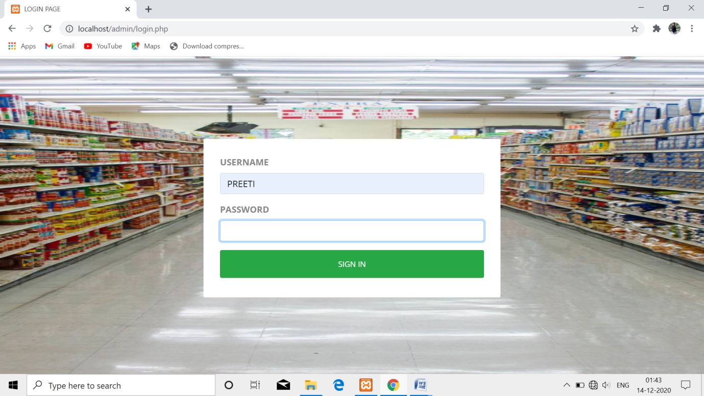

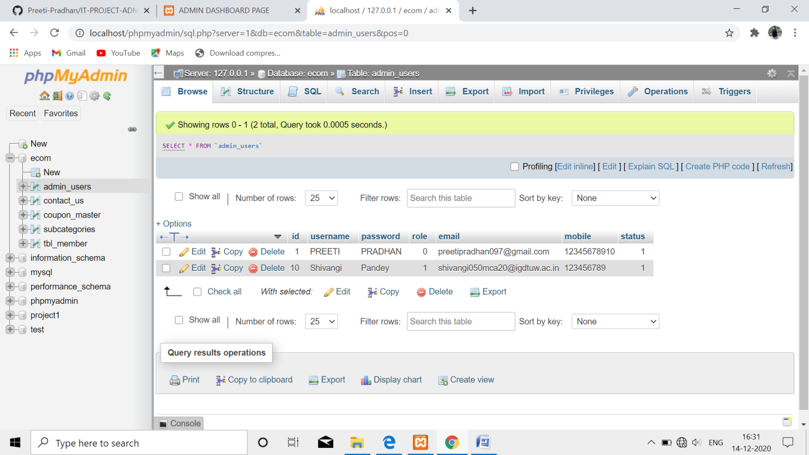

**VENDOR MANAGEMENT**

ADD VENDOR

There is a form that asks the admin to add vendor details by asking him/her to fill the required details that are

* USERNAME
* PASSWORD
* EMAIL
* MOBILE

Whenever the admin add details of vendors it get stored in the same database as of admin_users with role = 1. Whenever the admin clicks on the button name active and makes the vendor status deactive than it gets reflected into the database by specifying status = 0 (deactive) and if admin clicks on button edit then again the same form opens which tells the admin to edit the required detail. By clicking on delete button the detail of vendor got deleted from the database.

Database Name : ecom, Table Name : admin_users

|  |  |  |  |  |  |  |
| --- | --- | --- | --- | --- | --- | --- |
| id | username | password | role | email | mobile | status |
| 1 | Shivangi | Pandey | 1 | Shivangi050mca20@igdtuw.ac.in | 123456789 | 1 |

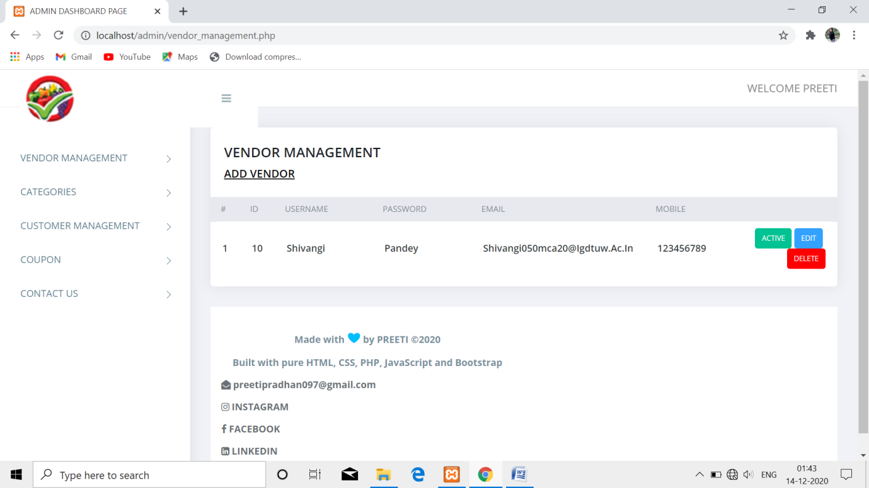

**CATEGORIES MANAGEMENT**

ADD CATEGORY

There is a form that asks the admin to add category details by asking him/her to fill the required details that is

* Category Name

Whenever the admin add details of category it get stored in the database. Whenever the admin clicks on the button name active and makes the category status deactive than it gets reflected into the database by specifying status = 0 (deactive) and if admin clicks on button edit then again the same form opens which tells the admin to edit the required detail. By clicking on delete button the detail of category got deleted from the database.

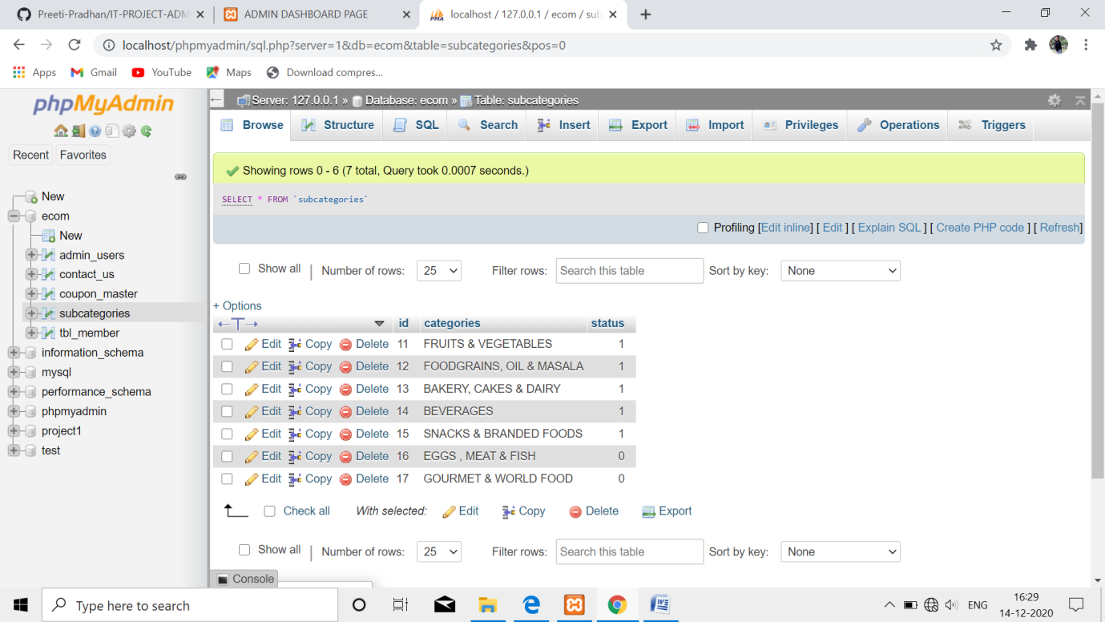

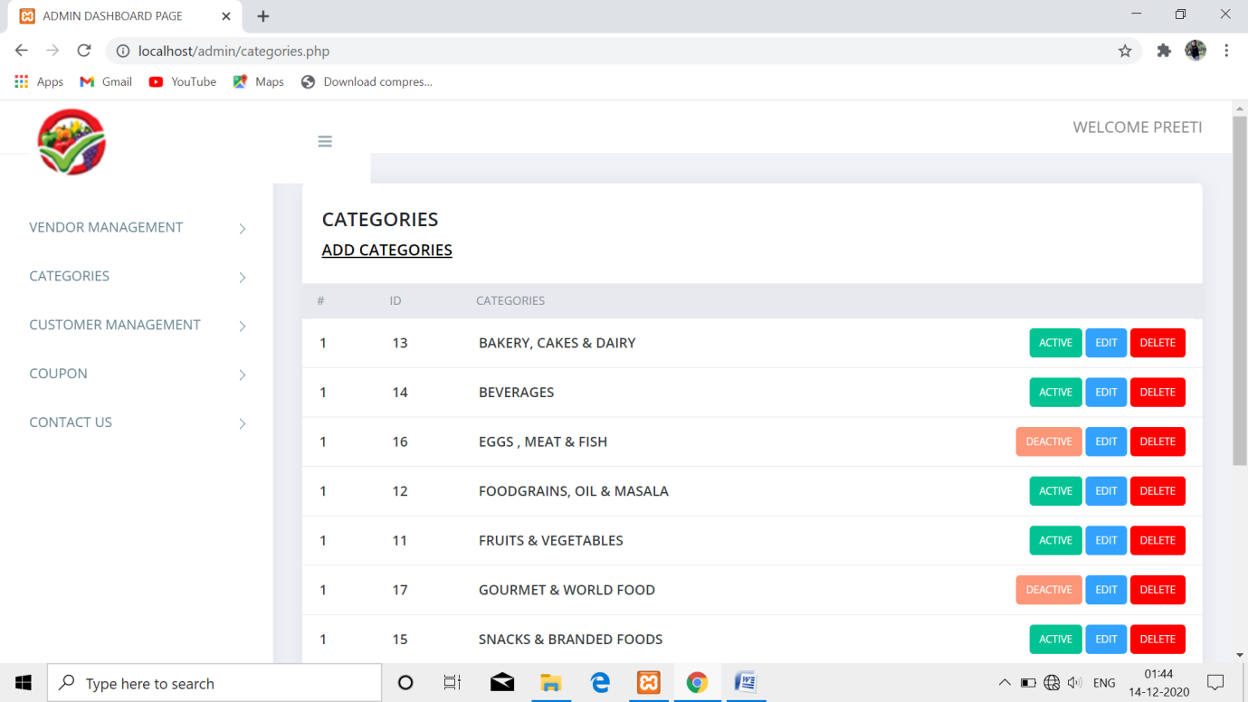

**CUSTOMER MANAGEMENT**

Whenever customer register into the system the information get stored in the database. The admin can delete the customer by clicking on delete button. Below is the required database table structure.

Database: ecom, Table: tbl_member

|  |  |  |  |  |
| --- | --- | --- | --- | --- |
| id | username | password | email | Create_at |

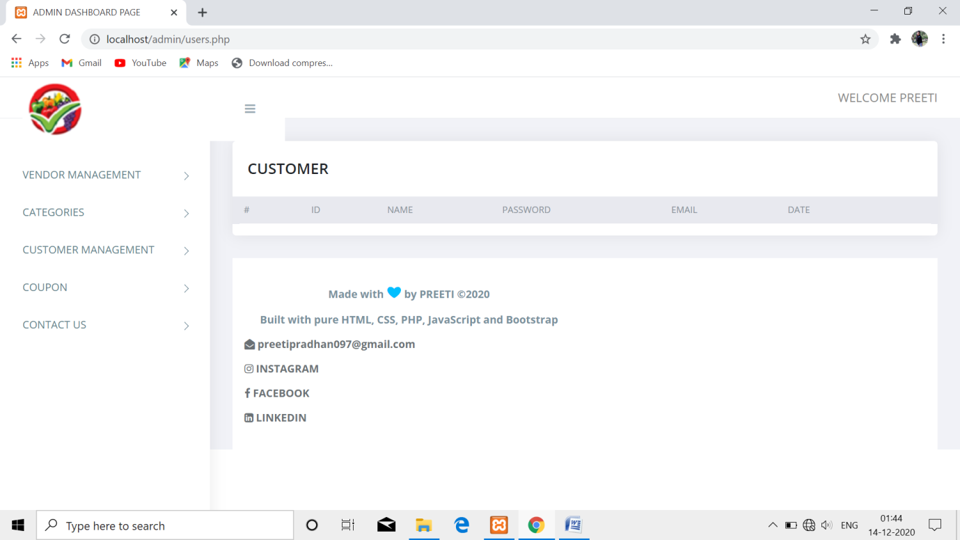

**COUPON DETAILS**

ADD COUPON

There is a form that asks the admin to add coupon details by asking him/her to fill the required details that is

* Coupon Code
* Coupon Value
* Coupon Type
* Cart Min Value

Whenever the admin add details of coupon it get stored in the database. Whenever the admin clicks on the button name active and makes the coupon status deactive than it gets reflected into the database by specifying status = 0 (deactive) and if admin clicks on button edit then again the same form opens which tells the admin to edit the required detail. By clicking on delete button the detail of coupon got deleted from the database.

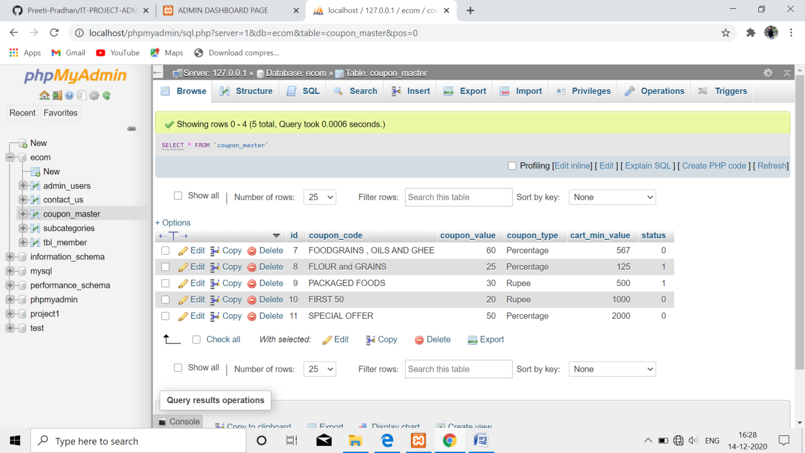

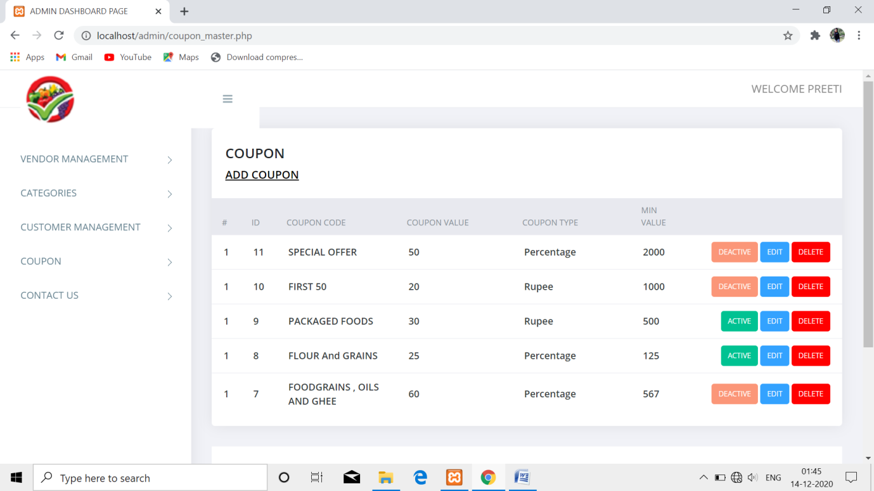

**CONTACT US**

If customer have any query he/she can contact to the below mentioned person. The information of all the vendors and users including the admin get stored in the database. The admin can delete the information by clicking on delete button. Below is the required database table structure

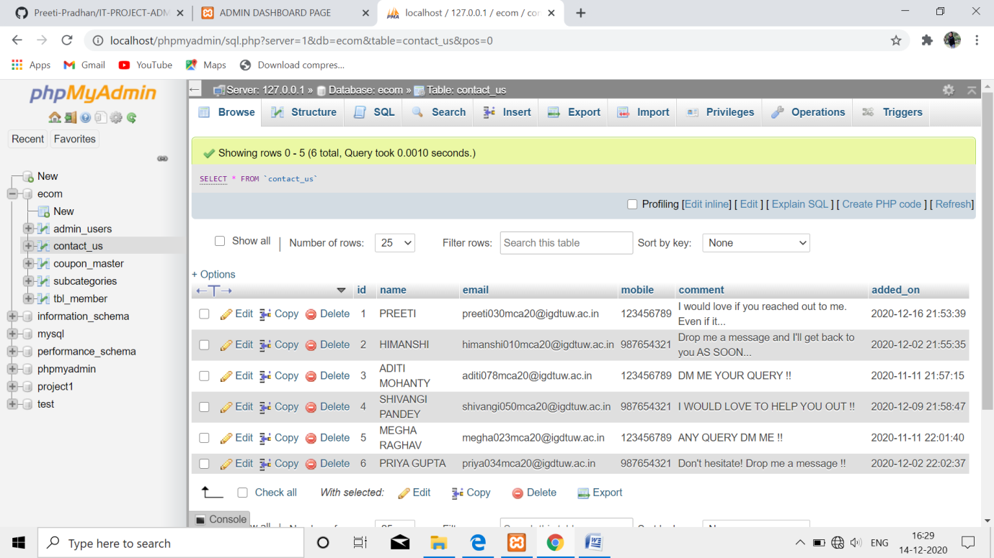

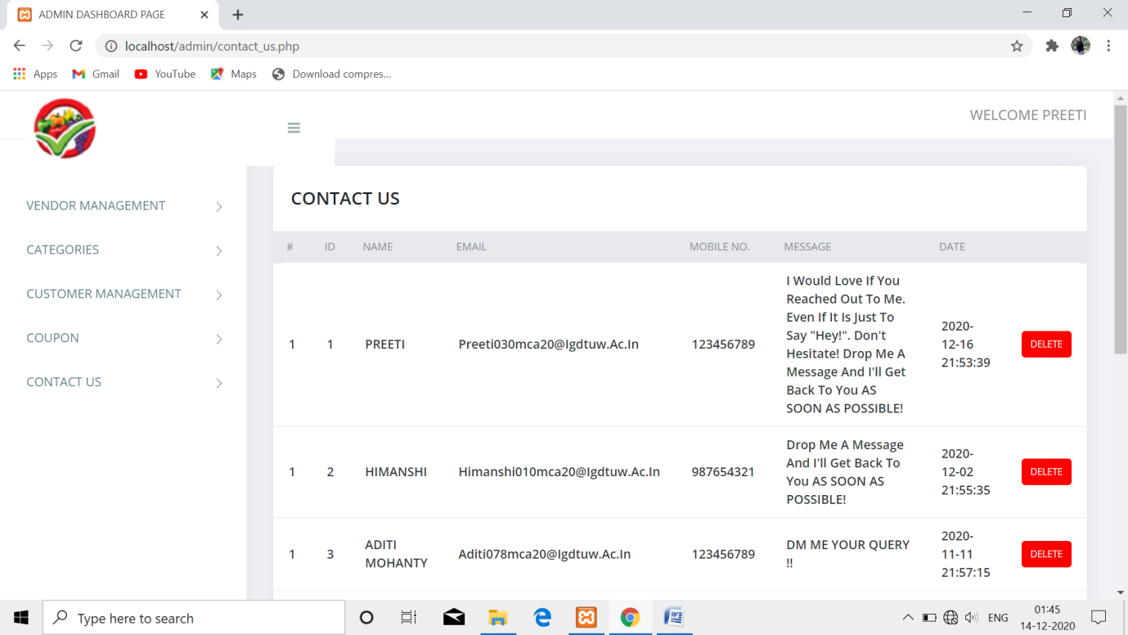

**My social media profiles (feel free to connect):-**

<https://github.com/Preeti-Pradhan>

<https://www.instagram.com/_preeti_pradhan_>?r=nametag

<https://www.facebook.com/preeti.pradhan.16752>

https://www.linkedin.com/in/preeti-93b72a1b5